WOMENS CAP SLEEVE  Adult - S , M , L , XL , 2XL  Girls - S , M , L  48% polyester/48% cotton/4% spandex rib-knit body  50% polyester/50% cotton 1x1 rib-knit sleeves |  |  | SHORT SLEEVE BASEBALL JERSEY  Adult - S , M , L , XL , 2XL , 3XL  Youth - S , M , L  50% polyester/50% cotton jersey knit
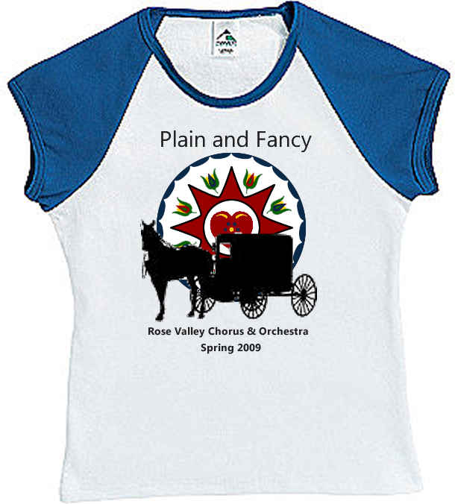  White/Navy |  |  | 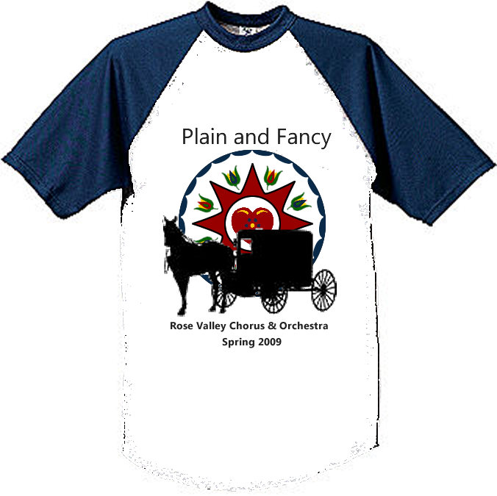  White/Navy
Name | Number | Style |  | Size
 |  | Cap Sleeve Baseball Youth |  | S M L XL 2XL 3XL
 |  | Cap Sleeve Baseball Youth |  | S M L XL 2XL 3XL
 |  | Cap Sleeve Baseball Youth |  | S M L XL 2XL 3XL
 |  | Cap Sleeve Baseball Youth |  | S M L XL 2XL 3XL
 |  | Cap Sleeve Baseball Youth |  | S M L XL 2XL 3XL
 |  | Cap Sleeve Baseball Youth |  | S M L XL 2XL 3XL
 |  | Cap Sleeve Baseball Youth |  | S M L XL 2XL 3XL
 |  | Cap Sleeve Baseball Youth |  | S M L XL 2XL 3XL
 |  | Cap Sleeve Baseball Youth |  | S M L XL 2XL 3XL
 |  | Cap Sleeve Baseball Youth |  | S M L XL 2XL 3XL
 |  | Cap Sleeve Baseball Youth |  | S M L XL 2XL 3XL
 |  | Cap Sleeve Baseball Youth |  | S M L XL 2XL 3XL
 |  | Cap Sleeve Baseball Youth |  | S M L XL 2XL 3XL
 |  | Cap Sleeve Baseball Youth |  | S M L XL 2XL 3XL
 |  | Cap Sleeve Baseball Youth |  | S M L XL 2XL 3XL
 |  | Cap Sleeve Baseball Youth |  | S M L XL 2XL 3XL
 |  | Cap Sleeve Baseball Youth |  | S M L XL 2XL 3XL
 |  | Cap Sleeve Baseball Youth |  | S M L XL 2XL 3XL
 |  | Cap Sleeve Baseball Youth |  | S M L XL 2XL 3XL
 |  | Cap Sleeve Baseball Youth |  | S M L XL 2XL 3XL
 |  | Cap Sleeve Baseball Youth |  | S M L XL 2XL 3XL
 |  | Cap Sleeve Baseball Youth |  | S M L XL 2XL 3XL
 |  | Cap Sleeve Baseball Youth |  | S M L XL 2XL 3XL
 |  | Cap Sleeve Baseball Youth |  | S M L XL 2XL 3XL
 |  | Cap Sleeve Baseball Youth |  | S M L XL 2XL 3XL
 |  | Cap Sleeve Baseball Youth |  | S M L XL 2XL 3XL

